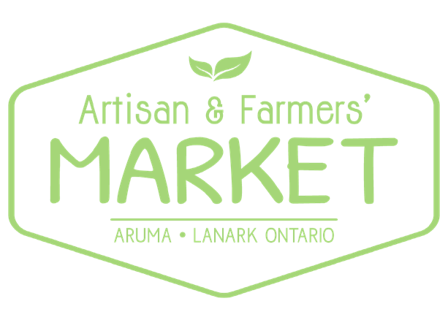
2104 Pine Grove Road, Lanark, ON | www.aruma.ca
613 259 3000 | haley@aruma.ca

Vendor Application Form

Thank you for your interest in becoming a vendor at the Aruma Artisan & Farmers’ Market. Our mission is to provide a space for friends, family, and community to gather, connect, and support local artisans and farmers along the banks of the Clyde River.
The market will run every Sunday from June 2 to September 29, 2019. The market is open from 9:00am until 1:00pm, and we ask that all vendors be set up and ready to go by 8:45am.
Please complete and return the following:

- This Vendor Application Form (signed).
- Once confirmed, full payment is required.
  - Payment can be made via e-transfer sent to haley@aruma.ca using password: market
  - OR via cash or cheque either mailed or dropped off in person.

Send:
- By Mail:
  - Aruma Artisan & Farmers’ Market
  - 2104 Pine Grove, Rd Lanark, ON K0G 1K0
- By email:
  - haley@aruma.ca

Contact Information

Company Name: _______________________________________________________
Contact Name: _________________________________________________________
Email Address: _________________________________________________________ Telephone: ____________________________________________________________ Website Address/Social media: ____________________________________________

Mailing Address

Address: ____________________________________________________________
City: _________________Province___________ Postal Code: __________________

Products to be sold & Description of business
(only products listed here are to be sold)
______________________________________________________________________
______________________________________________________________________
______________________________________________________________________
______________________________________________________________________
______________________________________________________________________
______________________________________________________________________ ______________________________________________________________________

Rates
No Hydro hook-up:
- Full Season (17 weeks) - $255 ($15 per week)
- Half Season (9 weeks) - $180 ($20 per week)
- Per Sunday - $25 (4 Sunday commitment required) With Hydro hook-up:
- Full Season (17 weeks) - $340 ($20 per week)
- Half Season (9 weeks) - $225 ($25 per week)
- Individual Sundays - $30 (4 Sunday commitment required)
**Prices include HST**

*Please Note: There will be no Market on August 18, due to the annual Roots on the Clyde Music Festival hosted by Aruma!

I will be attending as:

Full season vendor*: ____
Half Season vendor: ____
Per Sunday (please provide dates for a minimum of 4 Sundays):

__________________________________________________________________ __________________________________________________________________

Full season vendor w/hydro*: _____
Half season vendor w/hydro: _____
Per Sunday w/hydro (please provide dates for a minimum of 4 Sundays):
___________________________________________________________________ ___________________________________________________________________

*FULL season vendors will have their contact information listed on the Aruma website.

Rules and Regulations/Policies

- Vendor spaces will normally be a minimum of 10 feet in width by 10 feet in depth, or such width and depth as permitted by the market venue.

- Vendors are responsible for their own tables, chairs, tents, as desired/needed.

- Aruma and the Artisan & Farmers’ Market reserves the right to limit the number of vendors in a particular category (ie. Jewelery).

- Vendors must be fully setup by 15 minutes hour before market opens. Vehicles must be parked in the designated parking area half-an hour before market opens.

- Vendors are permitted to stand only within their allocated space and offer samples only within allocated spaces.

- The market is a non-smoking area and therefore vendors shall not smoke within 10 meters of the market.

- All vendors must stay until the end of the market. Vendors must plan to keep their entire setup in place until the market has closed. If a vendor has sold out, vendors are free to put up a sign to that effect and leave an empty booth. The booth itself, though, must remain setup until closing time.

- Food sampling can only happen when all health regulations are being followed.

- Proof of certification is required for foods identified as "organic". No use of the word organic, or any form of the word, can be used by a vendor unless certification is approved.

- Each vendor's allocated space is the vendor's responsibility and the ground beneath each space must be clean after use.

- Vendors shall treat the public, other vendors, and the market management team with courtesy and respect. Vendors shall not accost or badger the public.

- Space will be held only after full payment has been received. Once paid, date changes are not allowed and no refunds are given for cancellations.

Vendor Name (please print): _________________________________________

Vendor Signature: _________________________________________________

Date: ___________________________________________________________

